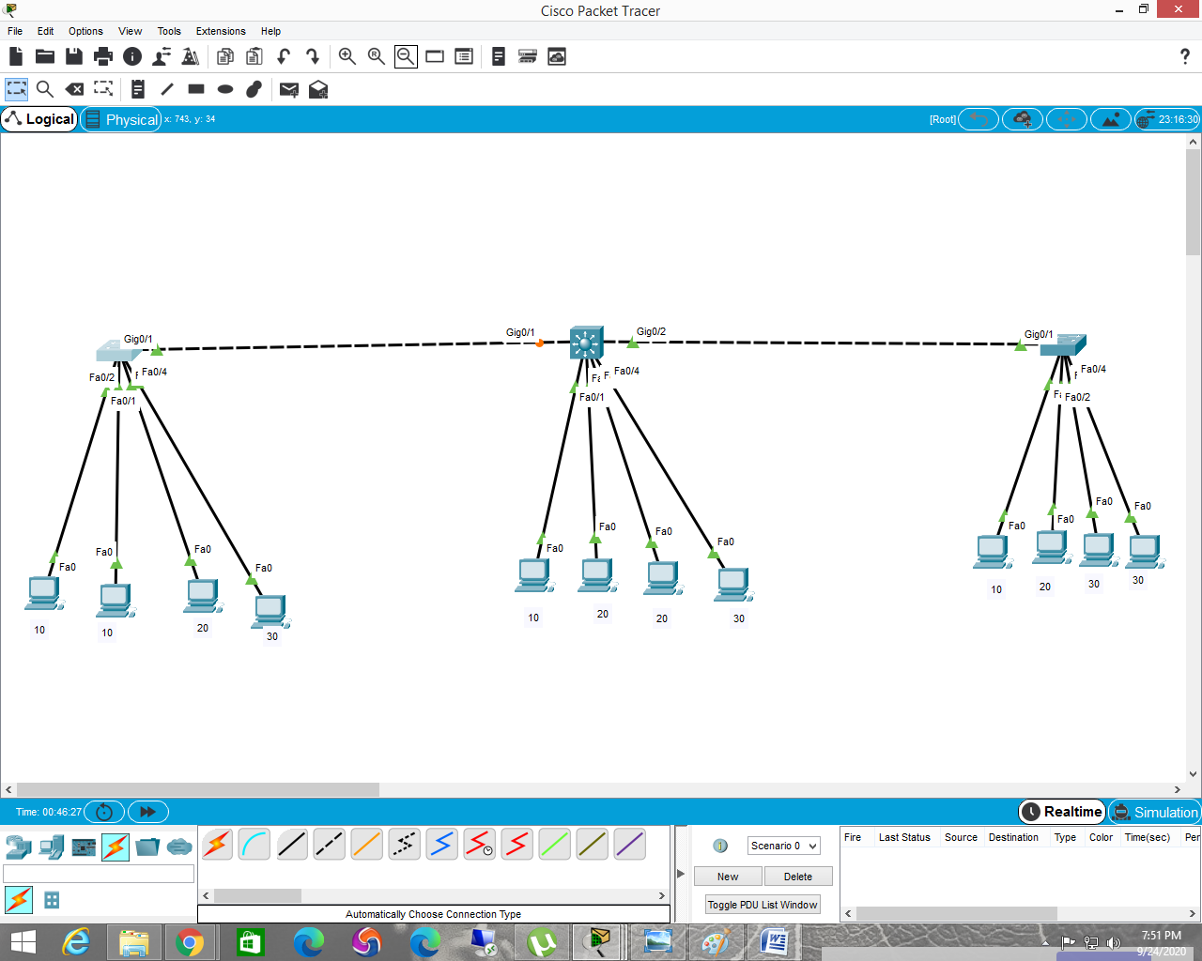

vlan configuration

======================

sw-1(config)#vlan 10

sw-1(config-vlan)#name pro

sw-1(config-vlan)#vlan 20

sw-1(config-vlan)#name sale

sw-1(config-vlan)#vlan 30

sw-1(config-vlan)#name acc

sw-1(config-vlan)#exit

sw-1(config)#interface range f0/1-2

sw-1(config-if)#switchport access vlan 10

sw-1(config-if)#interface fa0/3

sw-1(config-if-range)#switchport access vlan 20

sw-1(config-if-range)#interface f0/4

sw-1(config-if)#switchport access vlan 30

==================================================================

sw-2 vlan and trunk configuration

==========================

w-2(config)#vlan 10

sw-2(config-vlan)#name pro

sw-2(config-vlan)#vlan 20

sw-2(config-vlan)#name sale

sw-2(config-vlan)#vlan 30

sw-2(config-vlan)#name acc

sw-2(config-vlan)#exit

sw-2(config)#interface fa0/1

sw-2(config-if)#switchport access vlan 10

sw-2(config-if)#interface range fa0/2-3

sw-2(config-if-range)#switchport access vlan 20

sw-2(config-if-range)#interface fa0/4

sw-2(config-if)#switchport access vlan 30

trunk on sw-2

sw-2(config-if)#interface range g0/1-2

sw-2(config-if-range)#switchport trunk encapsulation dot1q

sw-2(config-if-range)#switchport mode trunk

==================================================================

sw-3 vlan configuration

======================

sw-3(config)#vlan 10

sw-3(config-vlan)#vlan 20

sw-3(config-vlan)#vlan 30

sw-3(config-vlan)#exit

sw-3(config)#interface fa0/1

sw-3(config-if)#switchport access vlan 10

sw-3(config-if)#interface fa0/2

sw-3(config-if)#switchport access vlan 20

sw-3(config-if)#interface range fa0/3-4

sw-3(config-if-range)#switchport access vlan 30

=================================================================

cmd to check vlan

switch#show vlan

=================================================================

intervlan configuration using router

Router on stick

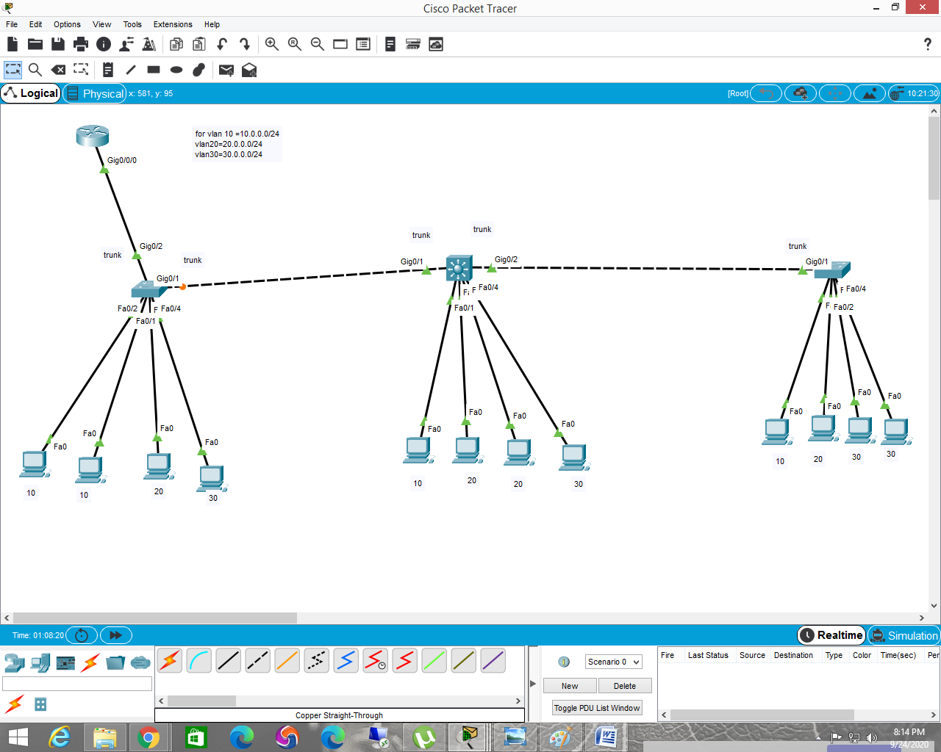

for router on stick we need to configure trunk on router connected port in the switch

sw-1(config)#interface g0/2

sw-1(config-if)#switchport mode trunk

================================================

router on stick configuration with dhcp on the router

R1(config)#interface g0/0/0.10

R1(config-subif)#encapsulation dot1q 10

R1(config-subif)#ip address 10.0.0.1 255.255.255.0

R1(config-subif)#interface g0/0/0.20

R1(config-subif)#encapsulation dot1q 20

R1(config-subif)#ip address 20.0.0.1 255.255.255.0

R1(config-subif)#interface g0/0/0.30

R1(config-subif)#encapsulation dot1q 30

R1(config-subif)#ip address 30.0.0.1 255.255.255.0

R1(config-subif)#

R1(config-subif)#interface g0/0/0

R1(config-if)#no shutdown

=====================================

dhcp configuration

R1(config)#ip dhcp excluded-address 10.0.0.1 10.0.0.50

R1(config)#ip dhcp excluded-address 20.0.0.1 20.0.0.50

R1(config)#ip dhcp excluded-address 30.0.0.1 30.0.0.50

R1(config)#ip dhcp pool v10

R1(dhcp-config)#network 10.0.0.0 255.255.255.0

R1(dhcp-config)#default-router 10.0.0.1

R1(dhcp-config)#ip dhcp pool v20

R1(dhcp-config)#network 20.0.0.0 255.255.255.0

R1(dhcp-config)#default-router 20.0.0.1

R1(dhcp-config)#ip dhcp pool v30

R1(dhcp-config)#network 30.0.0.0 255.255.255.0

R1(dhcp-config)#default-router 30.0.0.1

=================================================

svi switch virtual interface configuring in layer 3 switch

=======================================

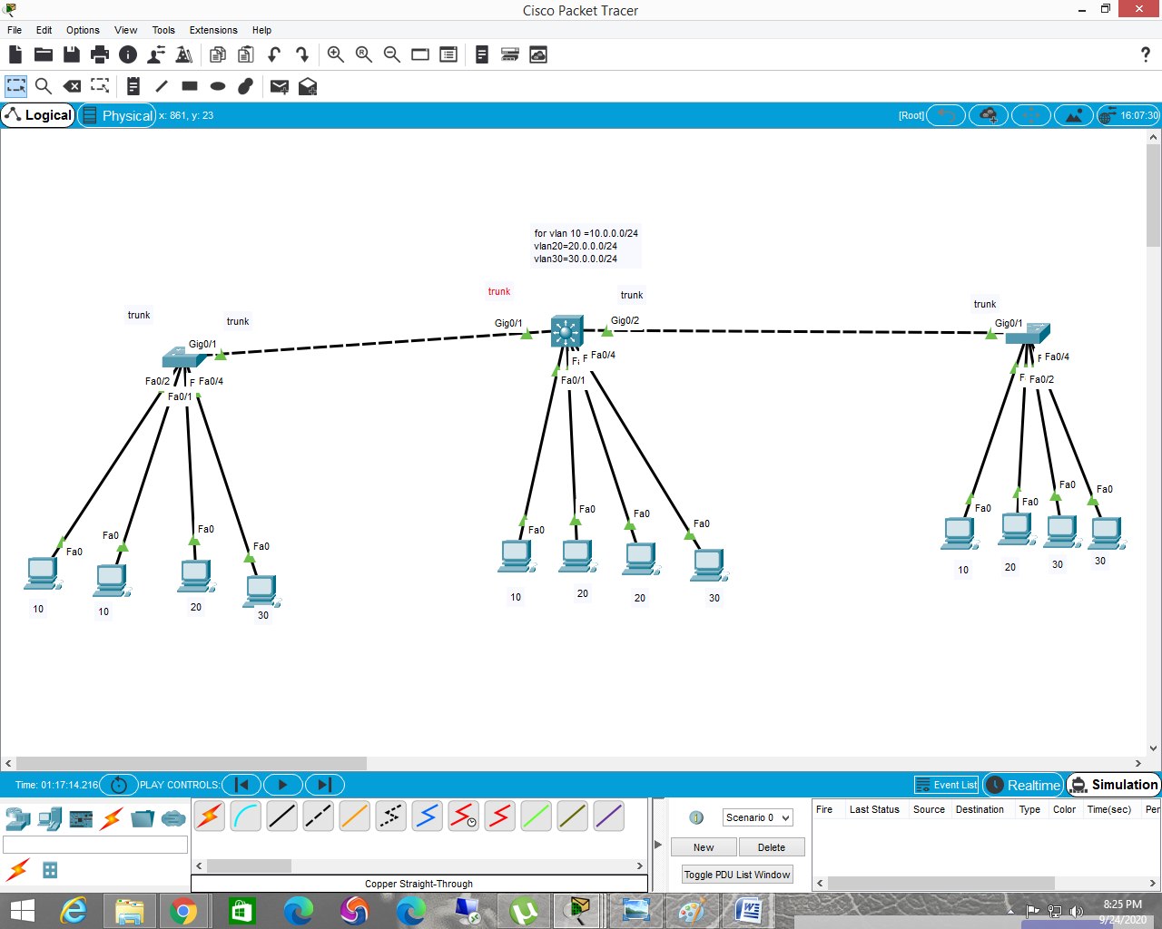

layer 3 switch routing with dhcp configuration cmd

sw-2(config)#ip routing

sw-2(config)#interface vlan 10

sw-2(config-if)#ip address 10.0.0.1 255.255.255.0

sw-2(config-if)#interface vlan 20

sw-2(config-if)#ip address 20.0.0.1 255.255.255.0

sw-2(config-if)#interface vlan 30

sw-2(config-if)#ip address 30.0.0.1 255.255.255.0

sw-2(config-if)#exit

sw-2(config)#ip dhcp excluded-address 10.0.0.1 10.0.0.15

sw-2(config)#ip dhcp excluded-address 20.0.0.1 20.0.0.15

sw-2(config)#ip dhcp excluded-address 30.0.0.1 30.0.0.15

sw-2(config)#ip dhcp pool v10

sw-2(dhcp-config)#network 10.0.0.0 255.255.255.0

sw-2(dhcp-config)#default-router 10.0.0.1

sw-2(dhcp-config)#ip dhcp pool v20

sw-2(dhcp-config)#network 20.0.0.0 255.255.255.0

sw-2(dhcp-config)#default-router 20.0.0.1

sw-2(dhcp-config)#ip dhcp pool v30

sw-2(dhcp-config)#network 30.0.0.0 255.255.255.0

sw-2(dhcp-config)#default-router 30.0.0.1

=======================================================

show ip route